Brake Coach Gauge Display – xEV – CGEA1.3

Functional Description

The purpose of the Brake Coach Gauge is to Display Brake Event Feedback Gauge (Brake Coach) to indicate the percentage (%) of regenerative braking energy recovered for a single stop.

The Brake Coach Gauge also correlates BrkEvntComplt_B_Dsply, RgenEvntLvl_Pc_Dsply and the Operational Mode to display the percentage of regenerative braking recovered for a single stop. This display/animation of the “Braking Coach” could be enabled or disabled based on the driver’s settings.

A unique settings menu HMI case is Cx727. The Cx727 vehicle has the Brake Coach Display settings menu in the Center Stack since there are no cluster input buttons. Note that Ford vehicles default to Brake Coach Display setting On, and Lincoln vehicles default to Brake Coach Display setting Off.

Brake coach display will be inhibited when the calm screen is active. First application for this update will be P702-BEV program.

Interfaces

Interface Context Diagram (I/O Block Diagram)
Brake Coach Gauge Context Diagram

Folder_Button_Hold_bit and M/C Switch Event inputs depends on IPC H/W configuration. For e.g. Cx727 does not have MC Switch interface.

Inputs

IR-REQ-312349/D-Internal:

- Operational Mode
- PT_Hyb_Cfg2
- Cluster_Dsply_Settings_Menu_Cfg (Unique to Cx727)
- Info_Btn_Cfg (from STSS - Steering Wheel Switch - SYNC 4.2 Specific CGEA1.3)
- M/C Display Status
- M/C Switch Event
- Calm_Screen_Active

MUX messages on the CAN Bus

SIG-REQ-312347/B-BrkEvntComplt_B_Dsply Signal

Signal  Name | Size  (bits) | Detail | Units | Resolution | Offset | State  Encoded | Min. | Max.
BrkEvntComplt_B_Dsply | 1 |  | SED | 1 | 0 |  | 0  (0x0) | 1  (0x1)
 |  | Off |  |  |  | 0x0
 |  | On |  |  |  | 0x1

SIG-REQ-312346/A-RgenEvntLvl_Pc_Dsply Signal

Signal  Name | Size  (bits) | Detail | Units | Resolution | Offset | State  Encoded | Min. | Max.
RgenEvntLvl_Pc_Dsply | 10 |  | % | 0.1 | 0 |  | 0  (0x00) | 1023  (0x3FF)
 |  | Unknown |  |  |  | 0x3FE
 |  | Faulted |  |  |  | 0x3FF

SIG-REQ-339157/A-CtrStkFeatConfigActl Signal

Signal Name | Size  (bits) | Detail | Units | Res. | Offset | State  Encoded | Min | Max
CtrStkFeatConfigActl | 16 | - | Undefined | 1 | 0 |  | 0  (0x0) | 65535 (0xFFFF)

SIG-REQ-339158/A-CtrStkFeatNoActl Signal

Signal Name | Size  (bits) | Detail | Units | Res. | Offset | State  Encoded | Min | Max
CtrStkFeatNoActl | 16 | - | Undefined | 1 | 0 |  | 0  (0x0) | 65535 (0xFFFF)

SIG-REQ-339159/A-CtrStkPersIndex_D_Actl Signal

Signal Name | Size  (bits) | Detail | Units | Res. | Offset | State  Encoded | Min | Max
CtrStkPersIndex_D_Actl | 3 |  | SED | 1 | 0 |  | 0 (0x0) | 7 (0x7)
 |  | PERS_1 |  |  |  | 0x0
 |  | PERS_2 |  |  |  | 0x1
 |  | PERS_3 |  |  |  | 0x2
 |  | PERS_4 |  |  |  | 0x3
 |  | Vehicle |  |  |  | 0x4
 |  | Unused_1 |  |  |  | 0x5
 |  | Unused_2 |  |  |  | 0x6
 |  | Unused_3 |  |  |  | 0x7

SIG-REQ-339160/A-CtrStkDsplyOp_D_Rq Signal

Signal Name | Size  (bits) | Detail | Units | Res. | Offset | State  Encoded | Min | Max
CtrStkDsplyOp_D_Rq | 3 |  | SED | 1 | 0 |  | 0 (0x0) | 7 (0x7)
 |  | Null |  |  |  | 0x0
 |  | Query |  |  |  | 0x1
 |  | Set |  |  |  | 0x2
 |  | Upload |  |  |  | 0x3
 |  | Restore |  |  |  | 0x4
 |  | Copy |  |  |  | 0x5
 |  | Unused_1 |  |  |  | 0x6
 |  | Unused_2 |  |  |  | 0x7

IR-REQ-312353/B-Outputs

brake_coach_display – Used to indicate the start of Brake Event Feedback Gauge Display for a single stop.
recaptured_energy_display – Used to indicate the amount of energy regenerated.

MUX signals to the APIM

SIG-REQ-339161/A-FeatConfigIpcActl Signal

Signal Name | Size  (bits) | Detail | Units | Res. | Offset | State  Encoded | Min | Max
FeatConfigIpcActl | 16 | - | Undefined | 1 | 0 |  | 0  (0x0) | 65535 (0xFFFF)

SIG-REQ-339162/A-FeatNoIpcActl Signal

Signal Name | Size  (bits) | Detail | Units | Res. | Offset | State  Encoded | Min | Max
FeatNoIpcActl | 16 | - | Number | 1 | 0 |  | 0  (0x0) | 65535 (0xFFFF)

SIG-REQ-339163/A-PersIndexIpc_D_Actl Signal

Signal Name | Size  (bits) | Detail | Units | Res. | Offset | State  Encoded | Min | Max
PersIndexIpc_D_Actl | 3 |  | SED | 1 | 0 |  | 0 (0x0) | 7 (0x7)
 |  | PERS_1 |  |  |  | 0x0
 |  | PERS_2 |  |  |  | 0x1
 |  | PERS_3 |  |  |  | 0x2
 |  | PERS_4 |  |  |  | 0x3
 |  | Vehicle |  |  |  | 0x4
 |  | Unused_1 |  |  |  | 0x5
 |  | Unused_2 |  |  |  | 0x6
 |  | Unused_3 |  |  |  | 0x7

Function/Performance

F-REQ-312354/A-Operational Modes

Mode | Differentiating Vehicle Conditions
Sleep Mode | Display off
Limited Mode | Display off
Normal Mode | Display On/Off
Crank Mode | Display On/Off

Voltage Levels

Refer to the Cluster Features table located in the Operational Modes and Voltage Range Strategies Section of this SPSS

Human-Machine Interface

Visual

Indicator Graphics / Display Format
Ford (Default ON)

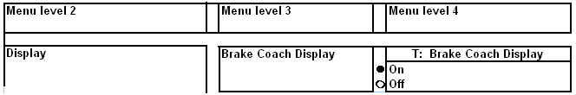

Lincoln (Default OFF)

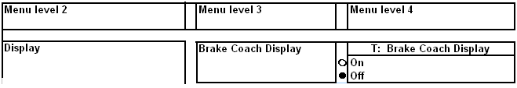

HMI-REQ-339164/A-“Brake Coach in Go Mode” Menu Setting for Cx727
- Unique to Cx727, when Cluster_Dsply_Settings_Menu_Cfg is set to 0x1 (Center Stack), the menu above is displayed in the Center Stack. This menu never appears in the cluster on Cx727. (Note Cx727 uses “Brake Coach in Go Mode” instead of just “Brake Coach Display”)
When Cluster_Dsply_Settings_Menu_Cfg is set to 0x0 (Cluster), there is no menu on a Cx727.

Brake Coach Graphics
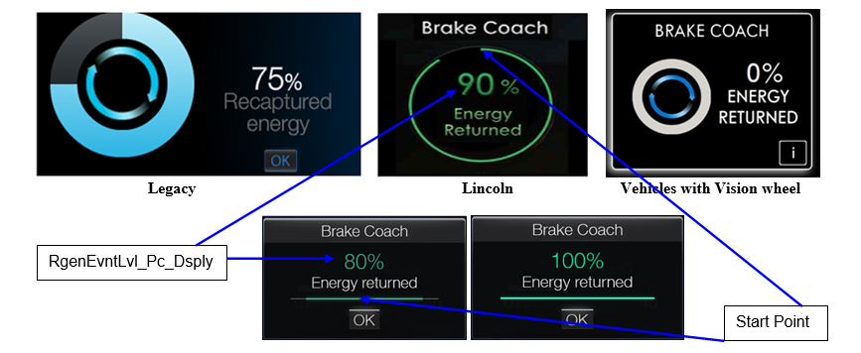

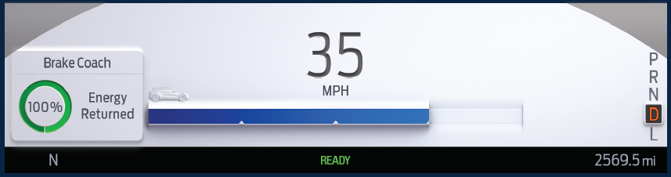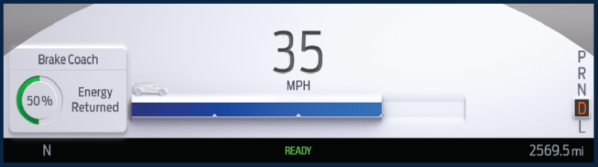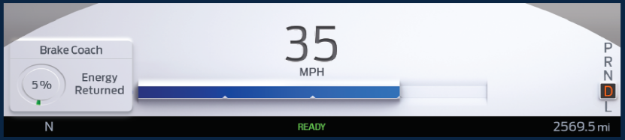
Brake Coach Gauge is placed in Left corner to ensure minimum movement in Gauge position based on different Display settings and Pop-ups.

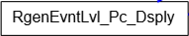
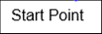
0% score is practically not possible in vehicle hence example not provided in this STSS. Although it can be requested if required for HMI implementation. Refer HMI specifications for more details.

HMI Examples for Cx727

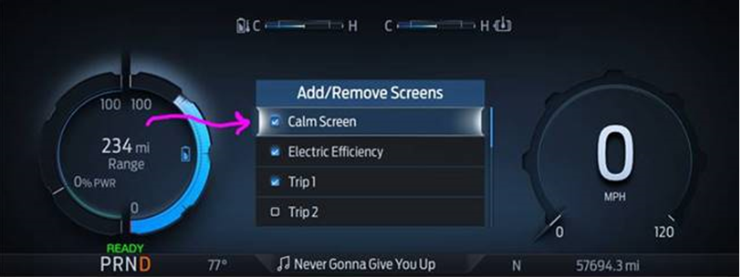
Calm Screen IOD
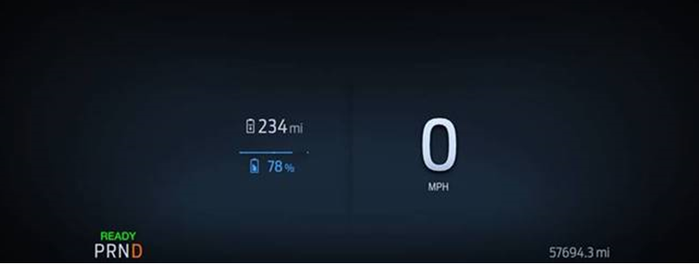
Calm Screen View
(i.e. Calm_Screen_Active = Yes) – Brake Coach Display is suppressed”

Sample Graphics for Brake Event Feedback Gauge for a single stop

HMI-REQ-312394/B-Energy Returned Display Design

Ford and Lincoln vehicles have a different design for energy returned.

HMI-REQ-312395/A-Gauge Percentage Fill Emanation Displays

For Ford vehicles the percentage fill emanates from the center of the bar while for Lincoln it’s a circular gauge.

HMI-REQ-312396/A-Graphics Variations

Ford and Lincoln have same function but different graphical look.

HMI-REQ-332900/C-Ford Vs Lincoln Default Menu Settings
Ford and Lincoln have different default Menu settings. In Ford vehicles default ‘Brake Coach Display’ is ‘ON’ while in Lincoln default ‘Brake Coach Display is ‘OFF’.

Info_Btn_Cfg | Brake Coach Display
YES (Lincoln)
NO (Ford)

Reference

Refer to the HMI Model(s) and specific graphics delivery for the exact Gauge Graphics

Indicator Color Coordinates

Refer to the COLOR & ILLUMINATION REQUIREMENTS (GRAPHICS) Section (1.7) of the Master SPSS File

Indicator Characteristics

HMI-REQ-312344/A-Gauge Fill Pattern

The Circular Gauge should fill clockwise starting at the top of the circle while arrows in the inner circle rotate.

Reference

Refer to the specific graphics/animation for timing and transitions.

Audio

None

Switch Control Logic

Not Applicable

PFM-REQ-312352/A-System Accuracy

Within 150 msec of receiving a message that results in a change of state the cluster will update the output.

Operation: Performance and Functional

DCR-REQ-413451/A-CAN Diagnositc Configuration Routine

F-REQ-312348/A-Subsystem Algorithm Flowchart / State Diagram

Operation Description (supports algorithm flowchart /state diagram)

Brake Event Feedback Gauge (Brake Coach) Display Controls:

F-REQ-312345/C-Brake Coach Display Setup

Brake Coach Display | M/C  Switch  Selection Event | Brake_Coach_Enabled
 | Up/Down + OK  (Select Off) | Off
 | Up/Down + OK  (Select On) | On
Note: The above menu does not appear in the cluster on Cx727. Also, the above menu appears in the cluster only when PT_Hyb_Cfg2 = (0x1 (BEV) OR 0x2 (FHEV) OR 0x3 (PHEV)).

F-REQ-339165/A-Brake Coach Menu Centerstack Signal Gateway Routine Flowchart

F-REQ-339166/A-Brake_Coach_Enabled based upon CtrStkFeatConfigActl

CtrStkFeatNoActl Signal | CtrStkFeatConfigActl  Signal | Display Menu  In Center Stack (For reference) | Brake_Coach_Enabled
0x0967 | On (0x1) | Brake Coach in Go Mode | On
0x0967 | Off (0x0) | Brake Coach in Go Mode | Off
0x0967 | Unused (0x2-0xFF) | Brake Coach in Go Mode | Off

F-REQ-339167/A-FeatConfigIpcActl State based upon Brake_Coach_Enabled

Brake_Coach_Enabled | Display Menu  In Center Stack  (For reference) | CtrStkFeatNoActl  Signal | FeatConfigIpcActl  Signal
On | Brake Coach in Go Mode | 0x0967 | 0x1 (On)
Off | Brake Coach in Go Mode | 0x0967 | 0x0 (Off)

F-REQ-387901/A-Brake Coach Display during active Calm Screen

Calm_Screen_Active | Brake_Coach_Enabled | brake_coach_display
Yes | OFF | OFF
Yes | ON | OFF
No | OFF | OFF
No | ON | ON  (As per Brake Coach Display Matrix-F-REQ-312342)
Brake Coach shall not be displayed when Calm screen is active

F-REQ-312342/C-Brake Coach Display State Matrix

Operational  _Mode | PT_Hb_Cfg2 | Brake_Coach_Enabled | Previous BrkEvntComplt  _B_Dsply | BrkEvntComplt  _B_Dsply | RgenEvntLvl  _Pc_Dsply | brake_coach  _display
Normal | 0x1 (BEV) || (0x2 (FHEV) || 0x3 (PHEV) | On (Default) | Off (0x0) | On (0x1) | 0 - 1000 | On (0x1)  Start “Brake Event Feedback” Display:  (animate circular gauge,  show recaptured_energy_display (%),  then animate battery glowing)
Normal | 0x1 (BEV) || (0x2 (FHEV) || 0x3 (PHEV) | On (Default) | On (0x1) | On (0x1) | 0 -1000 | On (0x1) - [unchanged]  (“Brake Event Feedback Gauge” already in display. Do not restart animation)
Crank | 0x1 (BEV) || (0x2 (FHEV) || 0x3 (PHEV) | x | x | x | x | Keep Last  Known value
All other cases |  |  |  |  |  | Off (0x0)  Stop/Exit/Hide “Brake Event Feedback” Display

F-REQ-312339/A-Brake Coach Display Transitions to ON

When brake_coach_display transitions to On, the animation of the “Brake Event Feedback Gauge” starts:

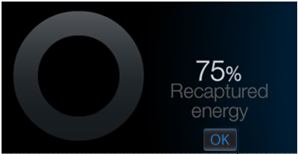
a. The circular gauge is unfilled, recaptured_energy_display is showing.

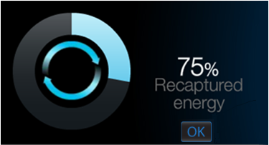
b. The circular gauge starts to get filled while arrows inside it are rotating.

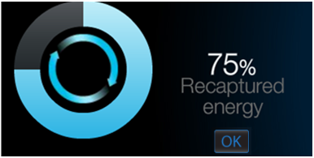
c. The circular gauge is filled proportional to recaptured_energy_display. In this example, ¾ of the circular gauge is filled since recaptured energy is 75%.

F-REQ-312340/A-Brake Coach Display Transitions to OFF

When brake_coach_display transitions to Off, the “Brake Event Feedback Gauge” display disappears.

F-REQ-312341/A-Removing Brake Event Feedback Gauge Display

Pressing the “OK” button removes the “Brake Event Feedback Gauge” display for Ford Vehicles. For Lincoln vehicles the Vision Wheel “i” button press event would remove the Feedback display

F-REQ-339168/A-Personalization Feature Number Definition

Feature Name | Feature Num | Cfg Num | Cfg Value
Brake Coach | 0x0967 | 0x0 | OFF / Disabled
Brake Coach | 0x0967 | 0x1 | ON / Enabled

FS-REQ-312356/A-Function Safety Classification (EMC)

B

NVM-REQ-312350/E-Memory Storage

Parameter Name | Description | Value at  Battery Connect | Value at  Module Wake-up
brake_coach_display | Used to indicate the start of Brake Event Feedback Gauge Display for a single stop | 0 (Off) | 0 (Off)
recaptured_energy_display | Used to display the of amount of energy recovered | 0 (%) | 0 (%)
BrkEvntComplt_B_Dsply  (CAN) Signal | CAN signal sent from the PCM to display brake event feedback. | As per CAN Message List | Do Not Init
RgenEvntLvl_Pc_Dsply  (CAN) Signal | CAN signal sent from the PCM for amount of energy recaptured. | As per CAN Message List | Do Not Init
Brake_Coach_Enabled | Used to Indicate Driver Setting/Selection to enable/disable the Brake Event Feedback Gauge display. | If, Folder_Button_Hold_bit = 0, On (Ford)  if Folder_Button_Hold_bit = 1, Off (Lincoln) | Use Stored Value
M/C Switch Event | Event that is indicated as per the switch interface for the Message Center. See * | See * below | See * below
Operational_Mode | 4 state indicator for cluster operational mode | Limited | Limited, Normal or Crank
Folder_Button_Hold_bit | One Bit indicator to differentiate “OK” and “Folder Button”. Eventually to differentiate between Ford and Lincoln in EV vehicles. | Disable | Disable
Info_Btn_Cfg | State Indicator for feature presence controlled via CAN at EOL at VO plant. | Use stored value | Use stored value
PT_Hyb_Cfg2 | State indicator for feature presence controlled via CAN at EOL at VO plant. Set to Disabled at Cluster Supplier Manufacturing Plant | Use stored value | Use stored value
Calm_Screen_Active | Calm screen IOD is selected and active | No | No
* Refer to Message Center X Display Y Button Interface Section, where X and Y are appropriate values in this document.

Prove Out

None

Error Handling

SR-REQ-312357/A-Gauge Display in Error Condition

The Brake Coach Gauge shall not be displayed when determining an error condition.

Missing/Invalid Message Strategy

The signals will be declared missing or invalid as per the Diagnostics section of this SPSS.

DTCs states and history will be determined as per the Diagnostics section of this SPSS.

Diagnostics

Self Test

None.

Engineering Test Mode

Reference section “Dealer / Engineering Test Mode (ETM)”

Part II Performance

DTC-REQ-312351/A-Supported Diagnostic Trouble Codes (DTCs)

DTC | Description
C29300 | Loss of Communication with HPCM
C59486 | Invalid Data Received from HPCM

DID-REQ-339169/C-DID $DExx

Block  Num | Block Description | Size (bits) | Byte(s) | Bit(s) | State: Description | "0" | "1" | Default | Comments/  Information
PACKETED BLOCKS
$0A | Option Content (B&A) | 1 | * | * | Cluster Display Settings Menu | Cluster | Center Stack | Cluster | This parameter allows the few remaining cluster display settings menu items to be displayed in the cluster when 0x0. When 0x1, the expectation is that cluster display settings are displayed in the Centerstack. At this time, this config has been created uniquely for Cx727, because the cluster does NOT have any steering wheel switch inputs at all. (And thus cannot have any menus at all)  At this time, only Cx727 will set this to 0x1. All other programs are 0x0 (or don’t support this bit).  It is expected that DE09 Settings_Menu_Cfg will also be 0x1 on the rare case that this config is set to 0x1. (i.e. All settings are in Center Stack). Note this is a global config, each feature still has its own config for presence on vehicle.
$0B | Option Content (B&A) | 1 | * | * | Info Button | NO | YES | NO | This parameter identifies if the Info button is available on the Steering Wheel. Info button, a.k.a. Folder button, is supported on Vision Steering Wheel, and is used to scroll through or Reset the Information On-Demand displays  Set to ‘YES’ on programs that have the Steering Wheel configured with Info / Folder button.
$09 | Option Content (B&A) | 3 | * | * | PT Hybrid2 (PT_Hyb_Cfg2)  0x0 = Non-Hybrid  0x1 = BEV  0x2 = FHEV  0x3 = PHEV  0x4 = MHEV |  |  | 0x0 | Default from cluster plant to be 0x0 if cluster can be used on a Non-Hybrid.  MHEV = Mild HEV  NOTE: 2-bit PT Hybrid config (DE01, Byte 5, Bits 7-6) is being phased out.
 | *Byte and bit location to be identified in Part II Specification for this cluster.

Reference Specification

None

Revision History
SPSS Module Revision History
Revision Level | Name | Change Description | Date
1.0 | SWatkins | Initial Release (Started with v1.1 (BEV only) and commonize for xEV)  - Charge_Mode temp. signal needs to be replaced with the actual CAN signal (future improvements for PHEV) | 5/20/11
1.1 | S. Watkins  M. Hakim | Reference Q/A 650: Fixed typo in the Subsystem Flowchart Diagram, in section 1.3.5.1 Also fixed same typo in section 1.3.5.2.2. c.  Reference Q/A 147: Added System Accuracy Statement, in section 1.3.4  Reference Q/A 41: Corrected Input Signals Tables, in section 1.2.2  Reference Q/A 648: Updated graphics with OK button and added OK button functionality statement, in sections 1.3.3.1.1 & 1.3.5.2.2  Reference Q/A 52: Added clarification point regarding “no filtering needed”, in section 1.3.5.2.2.  Reference Q/A 855: Replaced the temporary signal “Charge_Mode” with the correct signal “HybMdeStat_D_Dsply” all through the document. Added correct signal table, in section 1.2.2. Added signal mapping table, in section 1.3.5.2.2  Reference Q/A 38: Added DTC Table, in section 1.5.3  Moved Menu Structure graphics to section 1.3.3.1.1  Updated Menu Structure for “Regen Active” setup  Added input signal “LoadSettings” throughout the document for Key ID determination.  Added local input, “[L]_Battery_Display_Regen_Active_MC [x]” for “Regen Active” setup value. This input parameter was added to context diagram, input listing, and memory storage table.  Added Table 7, in section 1.3.5.2.1, for mapping of internal input of “Regen Actice” setting, “[L]_Battery_Display_Regen_Active_MC [x], to the parameter “Regen_Active_Enabled” that is used for this SSTS.  Fixed typo in Table 8, in section 1.3.5.2.1 “regen_display” | 10/5/11
2.0 | T. Cwik | Updated to include all states of input for mapping of Deplete/Sustain Mode on PHEV.  Section 1.3.5.1 – In Table 9,  — Added inputs of 0x0, 0x3, 0x6 & 0x7 to Deplete Mode  — Deleted input of 0x3 from Sustain Mode | 7/30/2012
3.0 | R. Chalanti | Clean up of STSS  Removed Battery Regen arrow indication related information from Brake Coach gauge display STSS as per U625 HMI Clinic directions and inputs from Dale Gilman & Craig Elser from EPE Team  Removed Load settings, HybMdeStat_D_Dsply signal.  Removed all past color coding to treat this a fresh STSS | 10/11/2016
4.0 | H. Sharma | Updated based on inputs from Dale Gilman from EPE Team  In Section 1.3.3.1.1, HMI updated for Energy Returned screens. Both Ford and Lincoln has deifferent graphics for Energy Returned, although NO difference in functionality. | 8/28/2017
4.1 | A. Mishra | Initial VSEM RM Release | 05/29/2018
4.2 | H. Sharma | This item was approved for spec update on 10/18 in DICC and brought in to DICC by Alec Struthers.  All the updates are marked in Turquoise color.  This change differentiate Ford and Lincoln for default Menu settings. ‘Brake Coach Display’ will be default OFF for Lincoln and default ON for Ford. | 10/24/2018
5.0 | S. Watkins | For Cx727, the remaining cluster display settings have to be moved to the Center Stack. This is because the cluster does not have any steering wheel button inputs. Specifically the “Brake Coach in Go Mode” menu item has to move. We have defined a new config for this, Cluster_Display_Settings_Menu_Cfg.  The “Brake Coach in Go Mode” checkbox is now Feature 0x0967 in the Center Stack. This is DI CC# 100217 from Daniel Menchaca.  Changes shown in yellow:  - Section 1.1 – Updated description  - Section 1.2.1 – Added 4 CAN signal inputs, 3 CAN signal outputs, and 1 new configuration to Context Diagram.  - Section 1.2.2.1 – Added new config bit  - Section 1.2.2.2.3-6 – Added 4 new CAN signals  - Section 1.2.3.1.1-3 – Added 3 new CAN signals  - Section 1.3.3.1.1 – Added HMI Requirement for Cx727.  - Section 1.3.3.1.1.1.4 – Corrected Typo.  - Section 1.3.5.2.1.2 – Added new Figure for Brake Coach Menu Centerstack Signal Gateway Routine Flowchart  - Section 1.3.5.2.1.3 - 4 - Added new Tables  - Section 1.3.5.2.1.5.4 – Added Feature Number Table  - Section 1.5.3.2 – Added new DE0A config | 1/5/2019
5.1 | H. Sharma | This update is also performed to add more details about Cx727 and make this STSS compatible to Cx727 and other future programs. Changes are marked in Bright Green color.  - One note is added to Section 1.2.1 Interface Context Diagram (I/O Block Diagram) to mention that M/C Switch inputs are not applicable to Cx727. All Switch related functionality is moved to CenterStack.  - Section 1.3.3.1.1.2 Brake Coach Graphics is also updated to add Cx727 specific graphics. | 01/18/2019
5.2 | James Raj. A  H. Sharma | This update replaces Folder_Button_Hold bit with an EOL config to make a distinct on the default menu settings for Brake Coach Display between Ford and Lincoln.  In addition, in this update Brake Coach display is disabled if Calm Screen is active. This request was brought to DICC by Charbel Bouery and approved offline by Scott Watkins on 04/29.DICC tracking #548.  Changes are marked in PINK:  - Section 1.2.1: Removed Folder_Button_Hold bit. Added EOL config Info_Btn_Cfg. Also added Calm_Screen_Active as input  - Section 1.2.2.1: Added EOL config Info_Btn_Cfg and Calm_Screen_Active flag  - Section 1.3.3.1.1.2 Brake Coach Graphics is updated to add Calm screen IoD HMI example.  - Section 1.3.3.1.1.2.4: Updated table for Brake Coach Display by replacing Folder_Button_Hold bit with Info_Btn_Cfg.  - New Section 1.3.5.1.5 F-REQ-387901 is added to disable Brake Coach display of calm screen is active.  - Section 1.3.5.4: Removed Folder_Button_Hold bit. Added EOL config Info_Btn_Cfg and Calm_Screen_Active  - Section 1.5.3.2: Added details for the DID DE0B parameter ‘Info Button’. | 05/12/2020
5.3 | James Raj A.  H. Sharma | This update associates the EOL config PT_Hyb_Cfg2 with the feature. This EOL config is required to have this feature implemented on common SW platform for Cluster on projects (for ex., Phoenix) involving Gasoline and xEV vehicle programs.  Changes made in Teal:  - Section 1.2.1, 1.2.2.1, 1.3.5.5: Added PT_Hyb_Cfg2.  - Section 1.3.5.1: Added section for CAN diagnostic configuration for PT_Hyb_Cfg2, Cluster_Dsply_Settings_Menu_Cfg, Info_Btn_Cfg.  - Section 1.3.5.3.1.1: Added to the note about Brake Coach Display dependency on PT_Hyb_Cfg2.  - Section 1.3.5.3.1.6: Added check for PT_Hyb_Cfg2 in the state matrix for Brake Coach Display.  - Section 1.5.3.2: Added DID DExx details for PT Hybrid_2. | 04/23/2021

